

I, the Roman Catholic Archbishop of Perth, mandate the Office of Christian Initiation to assist the Archdiocese in fulfilling its responsibilities in furthering the Mission of the Church in the area of Christian initiation of adults (RCIA), children (RCIC) and youth (RCIY) in accordance with the beliefs, values, traditions and social teaching of the Catholic Church.

The Office of Christian Initiation provides support to parishes to enable them to guide people on their conversion journey to deepen their relationship with Christ within the Catholic faith and tradition. This support is grounded in the Rite of Christian Initiation of Adults (RCIA) under the auspices of the Second Vatican Council Decree: 'By this means the time of the catechumenate, which is intended as a -period of well-suited instruction, would be sanctified by liturgical rites to be celebrated at successive intervals of time' (Sacrosanctum Concilium, 1963).

* Provide formation and training to RCIA teams to enable them to grow in their personal  
  relationship with Christ, their knowledge of Scripture and bearing witness to others
* Provide formation, training and resources for Parish Christian Initiation Teams with  
  age appropriate initiation of children (RCIC) and youth (RCIY) into the Church.
* Familiarise RCIA parish teams with the content of the Church's documents regarding  
  implementing the principles of RCIA in parishes
* Provide approved RCIA resource materials for the catechumenate teams
* Network with other Archdiocesan Adult Faith Formation agencies and organisations to promote the work of the mission and service of the Church

The Committee of Management is appointed by me and is governed by the Constitution that I have endorsed and which provides its brief to oversee the Office of Christian Initiation.

MISSION

PURPOSE

COMMITTEE OF MANAGEMENT



This Mandate is given for five years from the first day of January 2019.

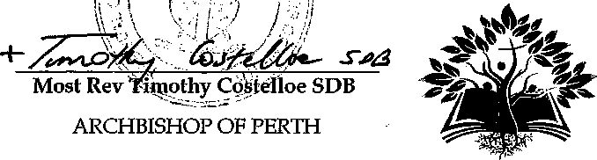

9\1\2019

Date